Lesson 06 Demo 2
Demonstrate YAML Scripting
Objective: To install NodeJS using YAML scripting

Pre-requisites: You need to have Ansible installed in order to proceed with this demo. If you don’t have it installed, refer to demo 1 of lesson 7.

Tools required: Ansible

Steps to be performed:
1. Create a playbook
2. Add YAML script to the playbook to install node
3. Run Ansible YAML script

Step 1: Create a playbook

1.1 Use the below command to create a node.yml file

sudo vi node.yml

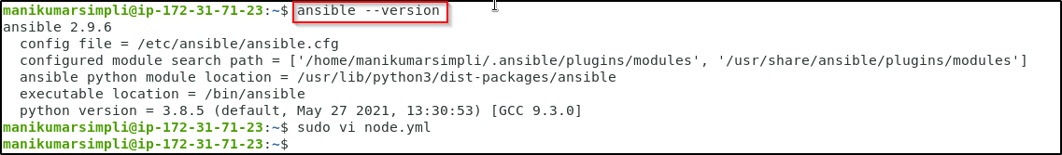

1.2 Establish SSH key pair in linux system to have SSH connectivity with localhost using the following commands:
ssh-keygen -t rsa (Press Enter when asked for File and Paraphrase details)
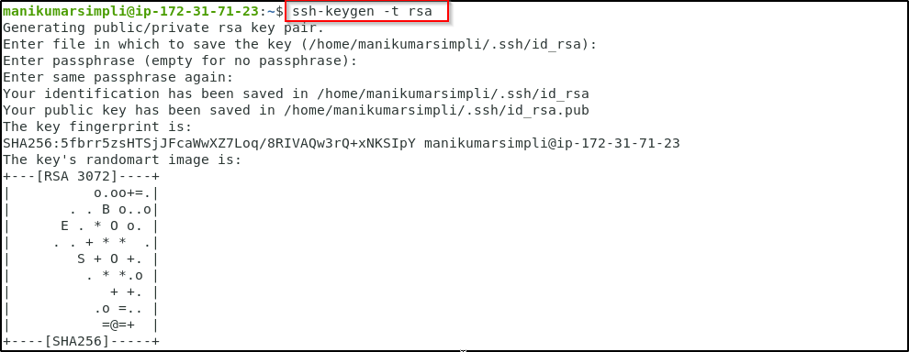
cat .ssh/id_rsa.pub >> .ssh/authorized_keys
ssh localhost -p 42006
(Type yes when prompted)
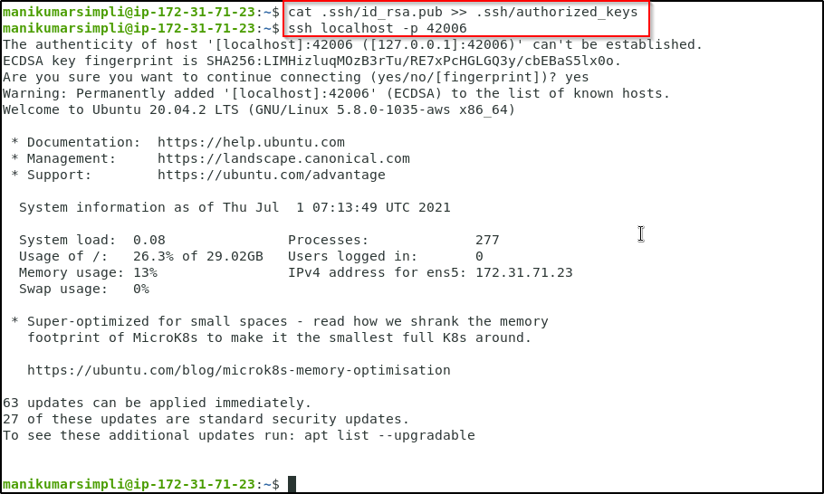

1.3 Now, add the host localhost in ansible host file /etc/ansible/hosts
sudo vi /etc/ansible/hosts
1.4 When the file opens, add the below two lines of the code at the end of the file:
[webservers]
localhost:42006

Step 2: Add YAML script to the playbook to install node

2.1 Open the node.yaml file by using the below command 2.2 and then add the following code

sudo vi node.yml

Copy paste the below code:

---

- hosts: webservers

become: true

tasks:

- name: add apt key for nodesource

become: true

apt_key: url=https://deb.nodesource.com/gpgkey/nodesource.gpg.key

- name: add repo for nodesource

become: true

apt_repository:

repo: 'deb https://deb.nodesource.com/node_0.10 {{ ansible_distribution_release }} main'

update_cache: no

- name: install nodejs

become: true

apt: name=nodejs

2.2 Save the file and exit using shift+esc+: and then type wq

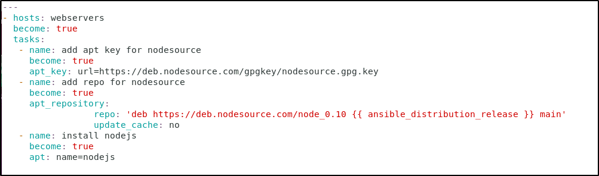

Step 3: Run Ansible YAML script

3.1 Run apache.yaml file using below command:

ansible-playbook node.yml
